Technical Document
Aniebiet Akpan

Contents
Externally sourced code
Critical algorithms
Advanced Techniques

Externally sourced code:
Playing Music:
java - Using javax.sound.sampled.Clip to play, loop, and stop multiple sounds in a game. Unexpected Errors - Stack Overflow
Database Connection
(From Scratch) Login Form with Access Database Connection in Java NetBeans Project |JDBC| UCanAccess - YouTube

AI chatbot code
https://chatgpt.com/share/68c4a6b9-fe64-8011-87c6-7c95b6edaa98

Critical algorithms:
- Connect Class:
This algorithm is essential to running my program as It allows for admin to view, update, delete and add into the tables in the database.

Pseudocode:
Pseudocode for the `Connect` Class

public method Connect()
begin
conn ← new Connection object
database ← "Database11.accdb"
try
Load database driver
conn ← establish connection to database using "jdbc:ucanaccess://" + database
display "Connection successful"
end try
catch any exceptions
display error message
end catch
end method

---

public method query(sql : string) : ResultSet
begin
rs ← null
try
stmt ← conn.createStatement()
rs ← stmt.executeQuery(sql)
end try
catch any exceptions
display error message
end catch
return rs
end method

---

public method modify(sql : string) : integer
begin
result ← 0
try
stmt ← conn.createStatement()
result ← stmt.executeUpdate(sql)
end try
catch any exceptions
display error message
end catch
return result
end method

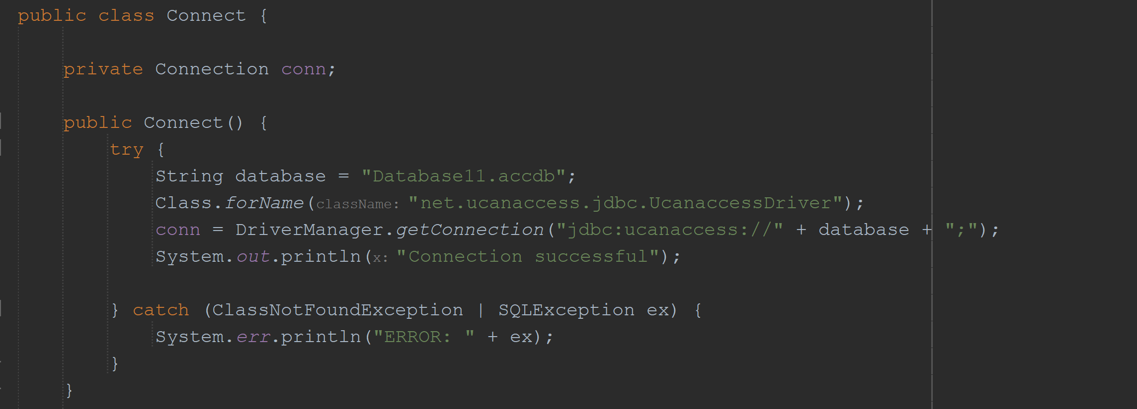
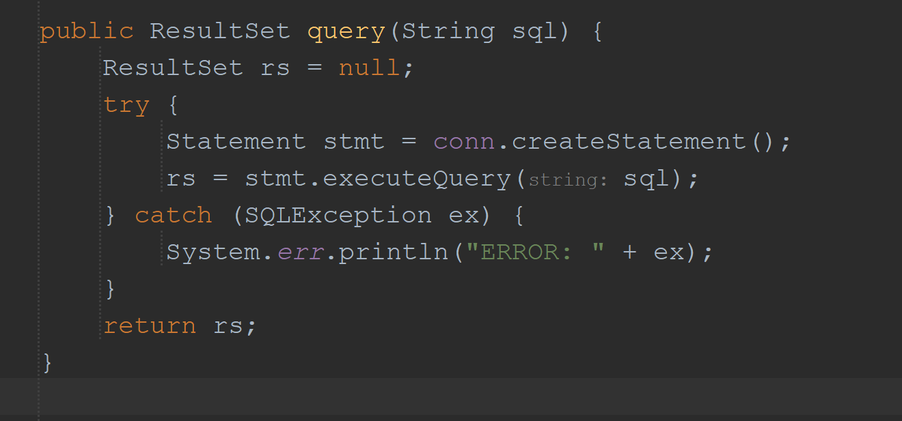
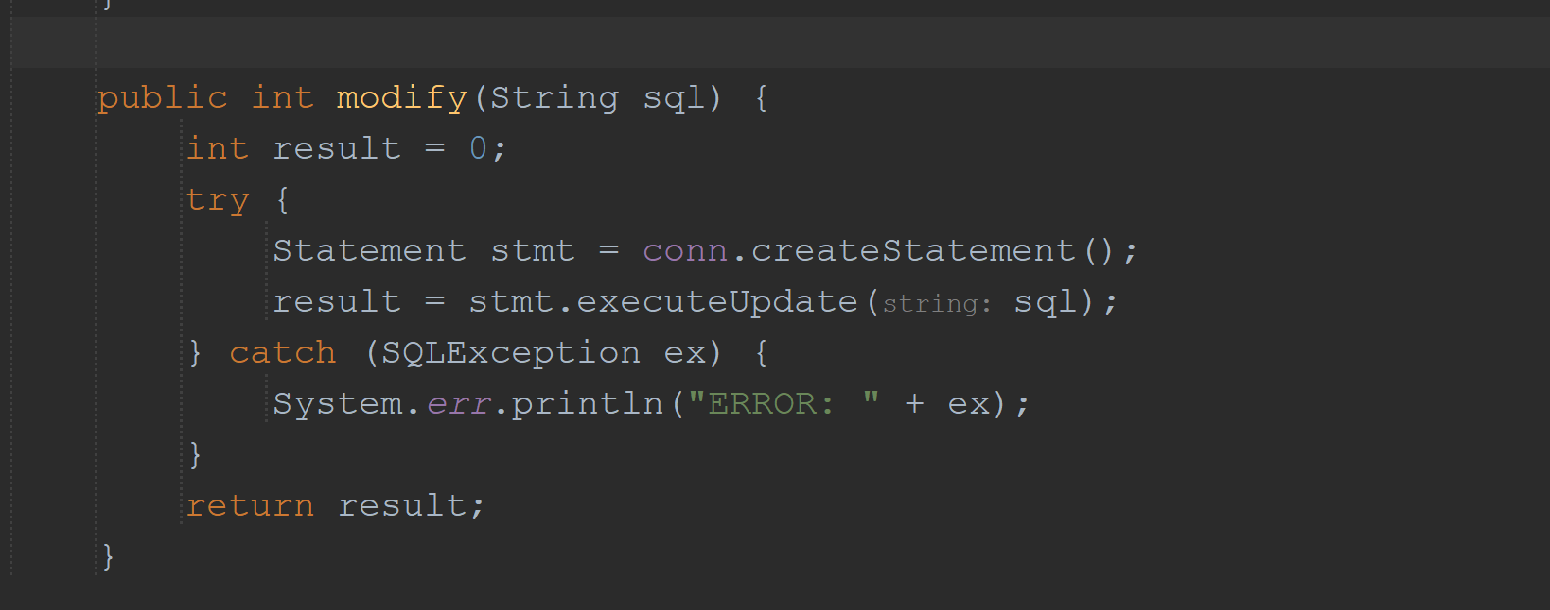

- Reading from text file for help.
This is essential as it makes it possible for users to gain a basic understanding of the program by displaying a text file which describes what the user can do.

Pseudocode:
public method show()
begin
try
begin
open file "Help.txt" for reading
output ← ""

while the file has data
begin
line ← read line from file
output ← output + line + "\n"
end while

display output
close file
end try

catch
begin
display "File not found"
end catch
end method
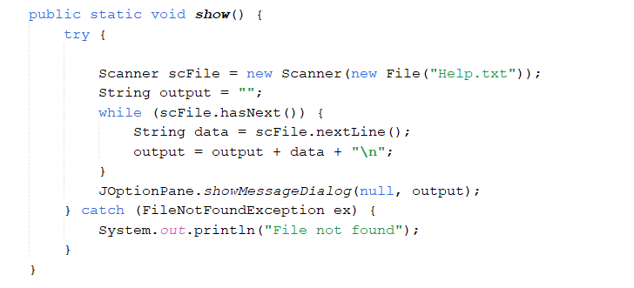
- Validation
Vaidates the users inputs into the UI to prevent any false data from being inputted e.g (Number for name).
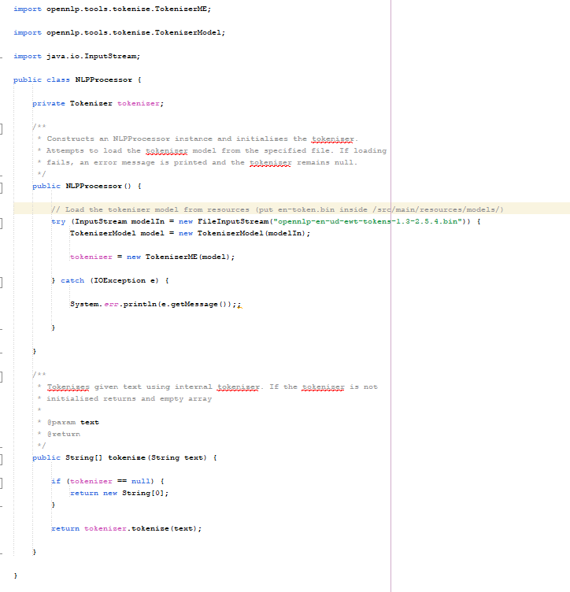
Pseudocode:
public method NLPProcessor()
begin
tokenizer ← null
try
modelIn ← open file "openulp-on-nd-over-token-1.0-2.5.4.bin" for reading
model ← new TokenizerModel(modelIn)
tokenizer ← new TokenizerME(model)
close file modelIn
end try
catch any exceptions
display error message
end catch
end method

---

public method tokenize(text : string) : string[]
begin
if tokenizer = null
return new string array of size 0
end if
return tokenizer.tokenize(text)
end method
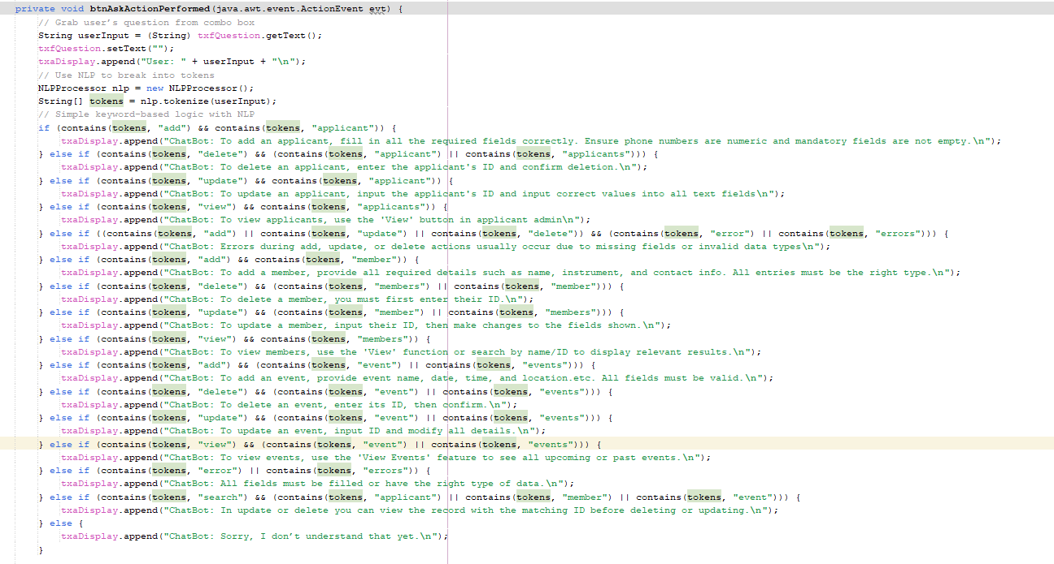
Pseudocode:
private method btnAskActionPerformed()
begin
input userInput
display "User: " + userInput
tokens ← split userInput into words
if "add" in tokens AND "applicant" in tokens
begin
display "ChatBot: To add an applicant, fill in all required fields correctly.
Ensure phone numbers are numeric and mandatory fields are not empty."
end if
else if "delete" in tokens AND ("applicant" in tokens OR "applicants" in tokens)
begin
display "ChatBot: To delete an applicant, enter the applicant's ID and confirm deletion."
end if
else if "update" in tokens AND "applicant" in tokens
begin
display "ChatBot: To update an applicant, input the applicant's ID and
enter correct values into all text fields."
end if
else if "view" in tokens AND "applicants" in tokens
begin
display "ChatBot: To view applicants, use the 'View' button in applicant admin."
end if
else if ("add" in tokens OR "update" in tokens OR "delete" in tokens)
AND ("error" in tokens OR "errors" in tokens)
begin
display "ChatBot: Errors during add, update, or delete actions usually occur
due to missing fields or invalid data types."
end if
else if "add" in tokens AND ("member" in tokens OR "members" in tokens)
begin
display "ChatBot: To add a member, provide all required details such as
name, instrument, and contact info. All entries must be the right type."
end if
else if "delete" in tokens AND ("member" in tokens OR "members" in tokens)
begin
display "ChatBot: To delete a member, you must first enter their ID."
end if
else if "update" in tokens AND ("member" in tokens OR "members" in tokens)
begin
display "ChatBot: To update a member, input their ID and make changes
to the fields shown."
end if
else if "view" in tokens AND ("member" in tokens OR "members" in tokens)
begin
display "ChatBot: To view members, use name/ID to display relevant results."
end if
else if "add" in tokens AND "events" in tokens
begin
display "ChatBot: To add an event, provide name, date, time, and location.
All fields must be valid."
end if
else if "delete" in tokens AND "events" in tokens
begin
display "ChatBot: To delete an event, enter its ID and confirm."
end if
else if "update" in tokens AND "events" in tokens
begin
display "ChatBot: To update an event, input ID and modify all details."
end if
else if "view" in tokens AND "events" in tokens
begin
display "ChatBot: To view events, use the 'View Events' feature to see all
upcoming or past events."
end if
else if ("errors" in tokens OR "error" in tokens)
begin
display "ChatBot: All fields must be filled or have the right type of data."
end if
else if "search" in tokens AND ("applicant" in tokens OR "member" in tokens OR "event" in tokens)
begin
display "ChatBot: In update or delete you can view the record with the matching
ID before deleting or updating."
end if
else
begin
display "ChatBot: Sorry, I don’t understand that yet."
end if
end method

Advanced Techniques:

- Playing music:
This code provides a simple system for handling background music in a Java program. It allows an audio file to be loaded, played in a continuous loop, paused, and then resumed without restarting from the beginning. By managing a single shared audio clip, it ensures that the music runs smoothly in the background while giving control over starting, stopping, and continuing playback. Essentially, it acts as a lightweight audio manager for looping background sound.
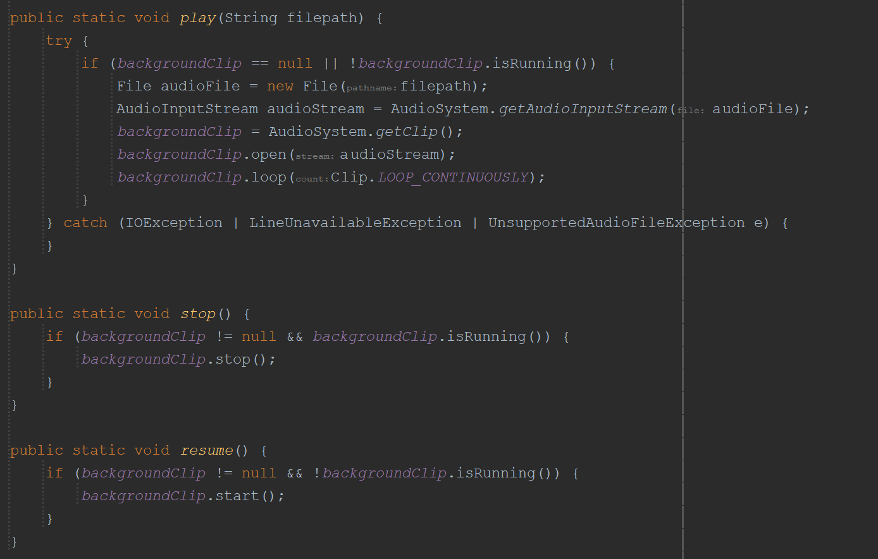

2. AI Chat Bot
Together, the NLPProcessor class and the btnAskActionPerformed method create a simple, keyword-driven chatbot that can interpret and respond to user input in a Java GUI application. When a user types a question or command into a text field and submits it (typically by clicking a button), the chatbot captures the text, displays it in the interface, and uses the NLPProcessor to break the input into individual words (tokens) using a pre-trained natural language processing model from Apache OpenNLP. These tokens are then checked against a set of predefined keywords using basic conditional logic. Based on which keywords are present—such as "add," "delete," "update," "view," along with context words like "applicant," "member," or "event"—the chatbot responds with helpful instructions or feedback specific to user actions within an application, such as managing applicants or scheduling events. If the input doesn't match any known patterns, the chatbot replies with a default message indicating it didn't understand the request. This approach allows for natural-sounding user interaction while relying
on a lightweight and easily extendable logic system.

3. Inheritance
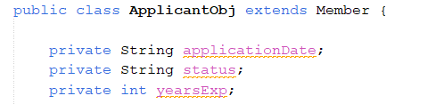
ApplicantObj is a child class of Member and therefore it inherits the ID, firstName, surname, phoneNumber , age and Instrument fields. This allows for an applicant to become a Member by connecting them on Java as opposed to a relationship table in access. It also allows for Applicant objects to make use of Member methods like .getFirstName() as opposed to having methods of their own.

